40 DAY LENT DEVOTIONAL
“A SEASON OF SELF-DENIAL & SUPERNATURAL RESULTS”
Enter to Worship Depart to Serve
Founded 1888
One of the oldest African-American Baptist churches in Lower Fairfield County

UNION BAPTIST CHURCH
805 NEW FIELD AVENUE
STAMFORD, CONNECTICUT 06905
Office (203) 322-0881
Fax (203) 322-3729
The Church Where the Spirit of God Reigns

Reverend Dr. Robert W. Perry
Senior Pastor

Reverend Dr. Michael G. Christie
Assistant to Pastor

40 Day Lent Devotional

“DANIEL FAST”
February 26, 2020 – April 11, 2020

“But Daniel made up his mind that he would not defile himself with the king’s choice food or with the wine which he drank; so he sought permission from the commander of the officials that he might not defile himself”
- Daniel 1:8

WHAT IS FASTING?
FASTING:
The Hebrew word translated “fasting” means literally to cover the mouth, which is to abstain from food or to fast for a duration of time. The Greek word nésteuó (pronounced nace-tyoo'-o) “not” and esthio (pronounced es-thee'-o) “eat” means to abstain from food for religious reasons. Therefore, to fast means to deny one’s self of food and other things believed to be needed for functioning, to place total dependence on God.
Much of our fasting is done on a personal level. Isaiah 58:6-8, gives a list of warnings as well as positive results that can occur when we submit ourselves to the discipline of fasting. Many of us consider fasting to be a private and inward act. Consequently, most of the focus on fasting is on a personal dimension. The purpose of fasting is to change us in ways that have a social and interpersonal impact. The Daniel Fast will focus on fasting for health and physical healing Daniel 1:12-20. The overall theme for the fast is “A Season of Self-Denial and Supernatural Results”.

WHY FAST?

While this fast is not mandatory, it is important that we come together to fast and pray as a church family. Fasting gives each of us an opportunity to strengthen ourselves spiritually and to overcome barriers that keep us from living a victorious life. God is able to move powerfully in our congregation if we set aside this time to fast and pray. We would like this fasting period to be a time that we individually and as a Church view our lives through the eyes of God.

- Fasting is a primary means of restoration. By humbling us, fasting releases the Holy Spirit to do His revival work in us.

- Fasting reduces the power of self so that the Holy Spirit can do more intense work within us.

- Fasting helps to purify us spiritually.

- Fasting increases our spiritual reception by quieting our minds and emotions.

- Fasting brings yieldedness, even holy brokenness, resulting in inner calm and self-control.

- Fasting renews spiritual visions.

- Fasting inspires determination to follow God’s revealed plan for your life.

Fasting for Lent
Lent serves as our annual invitation to come closer to God. It provides a time to look at our lives and ourselves, so we can identify the obstructions that keep us from God. We must remember that the Daniel Fast is for prevention, keeping you away from diseases, moving God to intervene as the Great Physician if you have already been stricken with a disease.
Included in this pamphlet is the optional forty-day fast with a meal plan that the entire congregation is asked to participate in during the time of Lent.
Lent begins Ash Wednesday (February 26, 2020) and ends on the Saturday before Easter (April 11, 2020). The word Lent comes from the Anglo-Saxon word Lenten, which means “spring,” the time of the lengthening of days. For Christians, Lent is a period of pondering God’s Gifts of love in the life, death, and resurrection of Jesus Christ. Just as Christ set aside time to pray and fast to prepare for His ministry, it is fitting for Christians to spend 40 days allowing the Holy Spirit to guide them into a deeper understanding of the sacrifice of Christ for their sins and what our individual response to the life, death, the resurrection should be.
Lent lasts forty days, not counting Sundays (because Sunday is the day on which Christ arose, making it an inappropriate day to fast and mourn our sins because we are focusing on how Jesus conquered death and how He saved us from our sins). On Sunday we must celebrate Christ’s resurrection for our salvation. It is Friday on which we commemorate his death for our sins. The Sundays of the year are days of celebration and the Fridays of the year are days of penance.

ASH Wednesday

The date of Ash Wednesday, determined by the date of Easter, may fall anytime between February 3rd and March 10th. Ash Wednesday begins the season of Lent with worship that focuses on the themes of sin and death in the light of God’s redeeming love in Jesus Christ. Traditional words used during the service are “Remember that you are dust, and to dust, you shall return.” We receive everlasting life only as a gift of God’s Grace.
Ash Wednesday Worship: Is the observance of Lent as a time of self-examination and repentance, of prayer and self-denial, of reading and bible study, of meditation on Jesus’ life and death, and of giving oneself to others, especially those who suffer and are in need.
Scripture has many references to ashes used as a sign or morality and of repentance (Genesis 18;26; Job 2:8; Jonah 3:5-10 and Luke 10:13).
Ashes from palms used on Palm Sunday of the previous year are burned and mixed with a little water to make ashes for Ash Wednesday. During the worship service, ashes are used to make a cross on the forehead of each worshiper.

Why 40 Days?
What’s so special about that time frame? The Bible is clear that God considers 40 days to be a spiritual resurrection time period. Whenever God wanted to prepare someone for His purposes, His took 40 days:
- Noah’s life was transformed by 40 days of rain.
  - Genesis 7:4
- Moses was transformed by 40 days on Mount Sinai.
  - Exodus 24:18
- The spies were transformed by 40 days in the Promised Land.
  - Numbers 13:35
- David was transformed by Goliath’s 40-day challenge.
  - Samuel 17:16
- Elijah was transformed when God gave him 40 days of strength from a single mean.
  - 1 Kings 19:8
- Jesus fasted 40 days and nights.
  - Matthew 4:2
- Jesus was tempted and empowered 40 days in the wilderness.
  - Luke 4:2, Mark 1:13
- Jesus remained on earth 40 days after the resurrection
  - Acts 1:3
- The disciples were transformed by 40 days with Jesus after His resurrection.
  - Acts 1:3
What is the Daniel Fast?
Purpose:
- Physical Healing and Initiation of a Healthier Lifestyle
– Isaiah 58; Exodus 15:26

- Spiritual Insight and Wisdom
– Daniel 1:17-21

- Spiritual Breakthrough
– Daniel 10:1-3
Focal Verse:
“But Daniel made up his mind that he would not defile himself with the king’s choice food or with the wine which he drank; so he sought permission from the commander of the officials that he might not defile himself” (Daniel 1:8).

Background:
Daniel and his friends deliberately went without the king’s special diet, forfeiting defiling themselves with the meat of the king’s table; but rather opted to have pulse (seed type food) to eat and water to drink.

Daniel Fast Entails:
- A spiritual commitment – “Daniel purposed in his heart (made up his mind) that he would not defile himself” (Daniel 1:8).
- Inner desire reflected by outer discipline – “I was mourning for three weeks; I did not each any pleasant bread (rich foods), meat or drink any wine…until the three weeks were passed” (Daniel 10:2-3).
- Increased Prayer Life – “He knelt down at the open windows and prayed to God three times a day and gave thanks to God” (Daniel 6:10) …fasting without prayer is meaningless.
- A statement of faith to others – “Then let our countenance be looked upon before thee and the countenance of the children that eat of the portion of the king’s meat…” (Daniel 1:13).
- Yielding all results to God – “…and as thou seest, deal with thy servants” (Daniel 1:13).

The Daniel Fast can lead to:
- Spiritual Insight and Wisdom – “As for these four children, God gave them knowledge and skill in all learning and wisdom: and Daniel had understanding in all visions and dreams” (Daniel 1:17).
- New Spiritual Direction and Effectiveness – “Then said he unto me, Fear not, Daniel…” (Daniel 10:12). Daniel, don’t be afraid, God has heard your prayers every since the first day you decided to humble yourself in order to gain understanding.
- Spiritual and Physical Health – “When the time was up, they looked healthier and stronger than those who had been eating the royal food” (Daniel 1:15).
- An Excellent Spirit and Favor among God and Man – “Then this Daniel was preferred about the presidents and princes, because an excellent spirit was with him; and the king thought to set him over the whole realm” (Daniel 6:3).

Remember these truths about fasting:
- Fasting loosen the bands of wickedness – “Is this not the fast that I have chosen? To loose the brands of wickedness, to undo the heave burdens, and to let the oppressed go free, and that ye break every yoke” (Isaiah 58:6).
- Fasting builds our faith – “Howbeit this kind goeth not out but by prayer and fasting” (Matthew 17:21).
- Fasting makes it easier to hear the voice of the Lord - “As they ministered to the Lord, and fasted, the Holy Ghost said, Separate me Barnabas and Saul for the work whereunto I have called them. And when they had fasted and prayed, and laid their hands on them, they sent them away” (Acts 13:2-3).

WEEK #1
SPIRITUAL POWER TO SURRENDER TO GOD

- Ash Wednesday, February 26, 2020
  - Read Psalm 51: 1-4

- Thursday, February 27, 2020
  - Read Psalm 143:8-9

- Friday, February 28, 2020
  - Read Romans 6:13-14

- Saturday, February 29, 2020
  - Read James 4:7-10

Daniel Fast Journal:

-------------------------------------------------------------------------------------------------------------------------------

-------------------------------------------------------------------------------------------------------------------------------

-------------------------------------------------------------------------------------------------------------------------------

-------------------------------------------------------------------------------------------------------------------------------

-------------------------------------------------------------------------------------------------------------------------------

-------------------------------------------------------------------------------------------------------------------------------

-------------------------------------------------------------------------------------------------------------------------------

-------------------------------------------------------------------------------------------------------------------------------

-------------------------------------------------------------------------------------------------------------------------------

-------------------------------------------------------------------------------------------------------------------------------

-------------------------------------------------------------------------------------------------------------------------------

-------------------------------------------------------------------------------------------------------------------------------

WEEK #2
SEEKING SPIRITUAL POWER TO LET GO

- Monday, March 2, 2020
  - Read Psalm 103:8

- Tuesday, March 3, 2020
  - Read Philippians 3:12-14

- Wednesday, March 4, 2020
  - Read 1 John 1:9

- Thursday, March 5, 2020
  - Read Isaiah 43:18-19

- Friday, March 6, 2020
  - Read Proverbs 28:13

- Saturday, March 7, 2020
  - Read Hebrews 12:1
Daniel Fast Journal:

-------------------------------------------------------------------------------------------------------------------------------

-------------------------------------------------------------------------------------------------------------------------------

-------------------------------------------------------------------------------------------------------------------------------

-------------------------------------------------------------------------------------------------------------------------------

-------------------------------------------------------------------------------------------------------------------------------

-------------------------------------------------------------------------------------------------------------------------------

-------------------------------------------------------------------------------------------------------------------------------

-------------------------------------------------------------------------------------------------------------------------------

-------------------------------------------------------------------------------------------------------------------------------
WEEK #3
SPIRITUAL POWER FOR CONTENTMENT

- Monday, March 9, 2020
  - Philippians 4:11-13

- Tuesday, March 10, 2020
  - Proverbs 15:13-16

- Wednesday, March 11, 2020
  - Matthew 6:19-33

- Thursday, March 12, 2020
  - Luke 12:48

- Friday, March 13, 2020
  - 1 Timothy 6:6-7

- Saturday, March 14, 2020
  - Hebrews 13:5
Daniel Fast Journal:

-------------------------------------------------------------------------------------------------------------------------------

-------------------------------------------------------------------------------------------------------------------------------

-------------------------------------------------------------------------------------------------------------------------------

-------------------------------------------------------------------------------------------------------------------------------

-------------------------------------------------------------------------------------------------------------------------------

-------------------------------------------------------------------------------------------------------------------------------

-------------------------------------------------------------------------------------------------------------------------------

-------------------------------------------------------------------------------------------------------------------------------

-------------------------------------------------------------------------------------------------------------------------------
WEEK #4
SPIRITUAL POWER FOR TRANSFORMATION

- Monday, March 16, 2020
  - Romans 12:2

- Tuesday, March 17, 2020
  - 2 Corinthians 5:17

- Wednesday, March 18, 2020
  - 1 John 3:2-3

- Thursday, March 19, 2020
  - Ephesians 4:29

- Friday, March 20, 2020
  - Philippians 1:6

- Saturday, March 21, 2020
  - Galatians 2:20
Daniel Fast Journal:

-------------------------------------------------------------------------------------------------------------------------------

-------------------------------------------------------------------------------------------------------------------------------

-------------------------------------------------------------------------------------------------------------------------------

-------------------------------------------------------------------------------------------------------------------------------

-------------------------------------------------------------------------------------------------------------------------------

-------------------------------------------------------------------------------------------------------------------------------

-------------------------------------------------------------------------------------------------------------------------------

-------------------------------------------------------------------------------------------------------------------------------

-------------------------------------------------------------------------------------------------------------------------------
WEEK #5
SPIRITUAL POWER FOR BREAKTHROUGH

- Monday, March 23, 2020
  - Micah 2:12-13

- Tuesday, March 24, 2020
  - Psalm 24:7-10

- Wednesday, March 25, 2020
  - Matthew 12:25-29

- Thursday, March 26, 2020
  - Genesis 22:15-19

- Friday, March 27, 2020
  - Isaiah 58:8-9, 11

- Saturday, March 28, 2020
  - Philippians 3:12-14
Daniel Fast Journal:

-------------------------------------------------------------------------------------------------------------------------------

-------------------------------------------------------------------------------------------------------------------------------

-------------------------------------------------------------------------------------------------------------------------------

-------------------------------------------------------------------------------------------------------------------------------

-------------------------------------------------------------------------------------------------------------------------------

-------------------------------------------------------------------------------------------------------------------------------

-------------------------------------------------------------------------------------------------------------------------------

-------------------------------------------------------------------------------------------------------------------------------

-------------------------------------------------------------------------------------------------------------------------------
WEEK #6
SPIRITUAL POWER TO SPEAK

- Monday, March 30, 2020
  - Proverbs 18:21

- Tuesday, March 31, 2020
  - 2 Corinthians 4:13, 18

- Wednesday, April 1, 2020
  - 1 Corinthians 1:28

- Thursday, April 2, 2020
  - Matthew 12:34-36

- Friday, April 3, 2020
  - Joshua 1:8

- Saturday, April 4, 2020
  - Mark 11:22-24
Daniel Fast Journal:

-------------------------------------------------------------------------------------------------------------------------------

-------------------------------------------------------------------------------------------------------------------------------

-------------------------------------------------------------------------------------------------------------------------------

-------------------------------------------------------------------------------------------------------------------------------

-------------------------------------------------------------------------------------------------------------------------------

-------------------------------------------------------------------------------------------------------------------------------

-------------------------------------------------------------------------------------------------------------------------------

-------------------------------------------------------------------------------------------------------------------------------

-------------------------------------------------------------------------------------------------------------------------------
WEEK #7
SPIRITUAL POWER TO WALK IN FREEDOM

- Monday, April 6, 2020
  - Isaiah 61:1-4

- Tuesday, April 7, 2020
  - Galatians 5:1

- Wednesday, April 8, 2020
  - Romans 6:18, 22

- Thursday, April 9, 2020
  - Galatians 5:13

- Friday, April 10, 2020
  - John 3:16-17

- Saturday, April 11, 2020
  - Romans 8:1

Daniel Fast Journal:

-------------------------------------------------------------------------------------------------------------------------------

-------------------------------------------------------------------------------------------------------------------------------

-------------------------------------------------------------------------------------------------------------------------------

-------------------------------------------------------------------------------------------------------------------------------

-------------------------------------------------------------------------------------------------------------------------------

-------------------------------------------------------------------------------------------------------------------------------

-------------------------------------------------------------------------------------------------------------------------------

-------------------------------------------------------------------------------------------------------------------------------

FASTING ON SUNDAY’S – OPTIONAL

It is our desire to have a true Lenten Fast which excludes Sundays from the days of observance. Listed below are scriptures for members who wish to go right through and include Sundays.

Sunday March 1, 2020 Exodus 15:26
Sunday March 8, 2020 3 John 2
Sunday March 15, 2020 Proverbs 3:7-8
Sunday March 22, 2020 Proverbs 4:20-23
Sunday March 29, 2020 Proverbs 16:24
Sunday April 5, 2020 Acts 27:34

AFTER THE DANIEL FAST

Ending the fast is equally important as its beginning. Just as you prepared yourself to start this fast, we encourage you to prepare yourself to stop or break your fast. Here are some questions you can ask yourself as you end this fast.

- What are the key lessons learned?
- Did you accomplish your goals?
- What new habits or disciplines do you want to keep?
- What new dietary rules will you follow?
- What dreams and visions have you seen pertaining to your personal walk with the Lord or your ministry involvement?
To maintain unity, we lift our concerns in prayer: Listed below are additional services held during Lent 2020 and for the remainder of the year.

Ash Wednesday Services
Wednesday, February 26, 2020
@ 12:00 noon
@ 6:00 pm

Bible Study
Wednesday’s @ 6:30 pm

Prayer and Praise Service
Wednesday’s @ 8:00 pm

- Pray for strength to keep the fast

- Pray for guidance

- Pray for the continued strength of Pastor Perry and the congregation

- Pray for new dimensions of faith

- Pray for understanding God’s direction

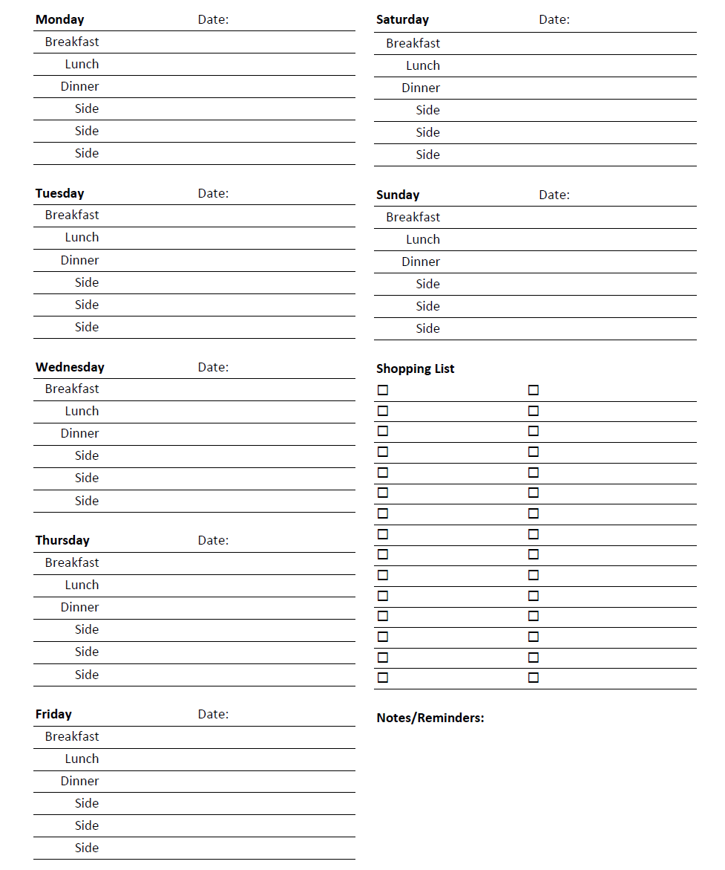

SUGGESTED FOODS WE MAY EAT

Whole Grains: Brown Rice, Oats, Barley

Legumes: Dried Beans, Pinto Beans, Split Peas, Lentils, Black Eyed Peas

Fruits: Apples, Apricots, Avocado, Bananas, Blackberries, Blueberries, Boysenberries, Cantaloupe, Cherries, Cranberries, Oats, Figs, Grapefruit, Grapes, Guava, Honeydew Melon, Kiwi, Lemons, Limes, Mangoes, Nectarines, Papayas, Peaches, Pears, Pineapples, Plums, Prunes, Raisins, Raspberries, Strawberries, Tangelos, Tangerines, Watermelon

Vegetables: Artichokes, Asparagus, Beets, Broccoli, Brussels Sprouts, Cabbage, Carrots, Cauliflower, Celery, Chili Peppers, Corn, Cucumbers, Eggplant, Garlic, Gingerroot, Greens, Leeks, Lettuce, Mushrooms, Okra, Onions, Parsley, Potatoes, Radishes, Rutabagas, Scallions, Spinach, Sprouts, Squashes, Sweet Potatoes, Tomatoes, Turnips, Watercress, Yams, Zucchini

Seeds, Nuts, Sprouts

Liquids: Spring Water, Distilled Water, 100% All-Natural Fruit Juices, 100% All-Natural Vegetable Juices

FOODS TO AVOID

Meat Refined Sugar
White Rice Sugar Substitutes
Fried Foods White Flour
Caffeine Margarine
Carbonated Beverages High Fat Products
Foods Containing Preservatives or Additives Shortening
High Fat Products

(Please do not hesitate to consult with your physician or healthcare professional if required)

May God renew and strengthen each of us through this fast

